**Ideation Phase**

**Define the Problem Statements**

|  |  |  |  |  |
| --- | --- | --- | --- | --- |
| Date | 19 OCTOBER 2022 | | | |
| Team ID | PNT2022TMID16911 | | | |
| Project Name |  | Industry-specific intelligent fire | |  |
| management system |  |
| Maximum Marks | 2 Marks | | | |

**Customer Problem Statement Template:** PS-1

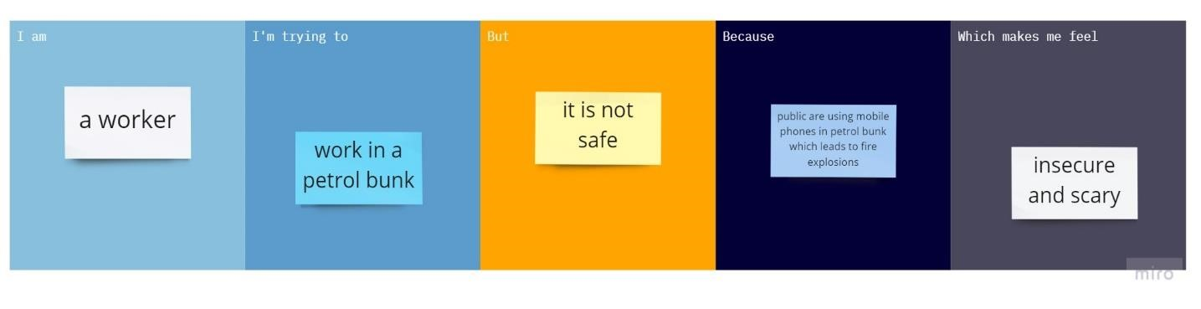

# PS-2

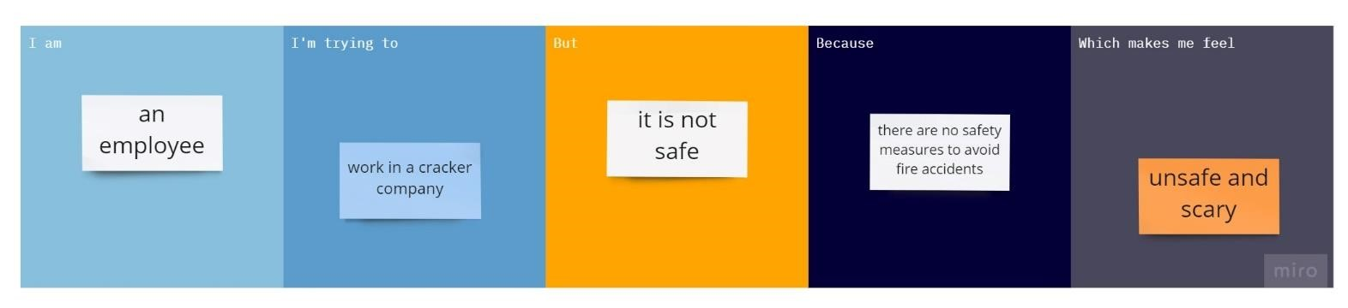

|  |  |  |  |  |  |
| --- | --- | --- | --- | --- | --- |
| **Problem**  **Statement (PS)** | **I am** | **I’m trying to** | **But** | **Because** | **Which makes me feel** |
| PS-1 | A worker | Work in a petrol bunk | It is not safe | Public are using mobile phones in petrol bunk  which leads to fire explosion | Insecure and scary |
| PS-2 | An employee | Work in a cracker company | It is not safe | There are no safety measures to avoid fire accidents | Unsafe and secury |